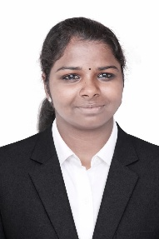
ANUSUYA S RESUME
5/14,
Soludaiyampatti,(post)
Tirumalaipatti, (Tk),
Namakkal (dt) – 637404
anusuyasuguamr@gmail.com
Mobile no:9345564975

OBJECTIVE:
To start my career in a challenging and growth-oriented organization where I can utilize my technical skills, learn new skills, and contribute to the growth of the organization.

ACADEMIC PROFILE:
Academic | School & College | Board & University | Percentage | Year of passing
DIPLOMA | K.S.R Institute of  Technology,  Tiruchengode. | Dote  (Chennai) | 96% | 2027
SSLC | Private study | State Board  (Tamil Nadu) | 47.2% | 2023

PERSONALITY TRAITS:
- Quick learner and willing to learn new skills.
- Ability to work effectively in a team.
- Good time management and punctuality.
- Positive attitude towards work.
- Ability to adapt to new working environments.
- Hardworking and responsible.

TECHNICAL SKILLS:
- PYTHON
- JAVA
- MYSQL
- HTML
- MS WORD
- MS EXCEL
- BASIC COMPUTER SKILLS

ACADEMIC PROJECT:
Gen AI Powered Career Guidance and Personalized Interview Preparation System. I am currently developing this project using Generative AI, OpenAI, Python, and JavaScript.

ACHIVEMENTS:
- Secured first mark in college
- Participated in technical activities and college events.
- Actively participated in workshops and technical symposiums.

PERSONAL PROFILE:
Name : ANUSUYA S
Father’s Name : SUGUMAR P
Date of Birth : 13/09/2006
Languages Known : Tamil &English (Read, Write)

DECLARATION:
I hereby declare that all the information provided above is true and correct to the best of my knowledge and belief.

